Research Topic: EDUSYS

The EduSys College ERP is the cloud-based college management software system that automates the entire campus operations, reduce operating cost and engage or save more time by bringing management, professor, staff, parent, and students under one roof.

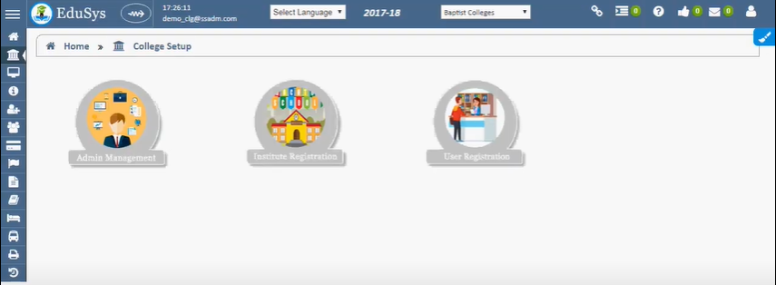DASHBOARD

**Features:**

* Staff Management System
* Branch Management
* Student Management
* Human Resource Management
* Visitor Management
* Document Management
* Fee Management
* Placement Management
* Report Management
* Exam Management
* Admission Management
* Hostel Management
* Library Management
* Attendance Management

**Here is a list of technologies that power the core of EDUSYS:**

**Framework:** .Net Framework: provides a comprehensive and consistent programming model for building Windows-based applications, web applications, and services.

**Programming language:** C#, Visual Basic, and F#

**Frontend**: Blazor

**App:** Android & iOS

**Browser Support:**  Chrome, Mozilla Firefox, Internet Explorer, and others.

**Database**: Microsoft SQL Server

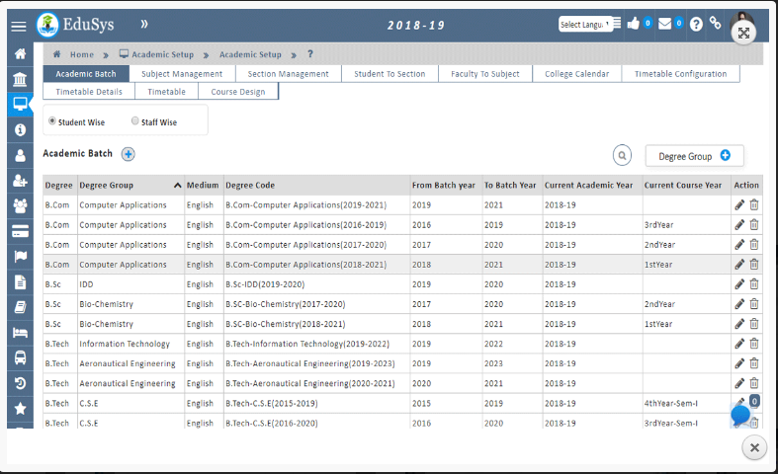

ACADEMIC SETUP

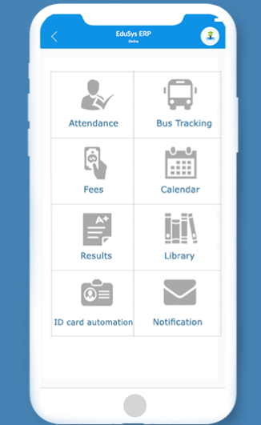 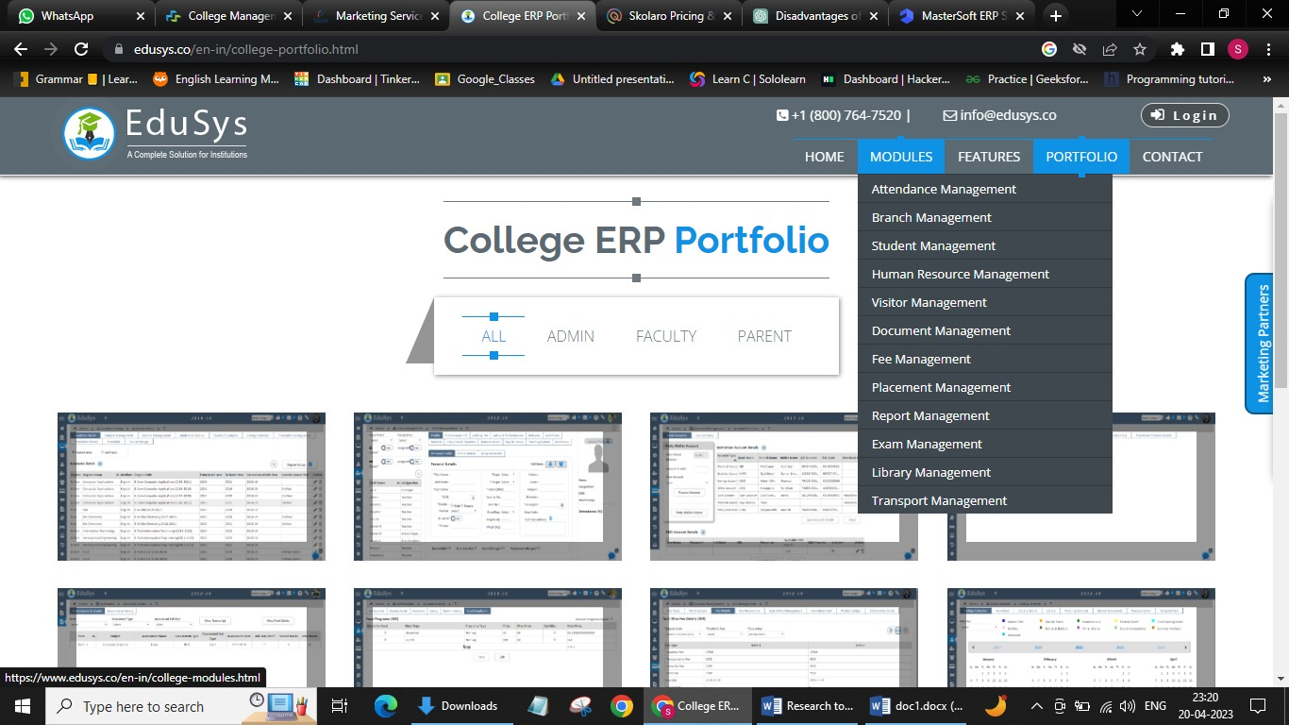

COLLEGE MANAGEMENT APP MODULES

**Disadvantages of EDSYS:**

### **1. Cost:**

Starting price of the Edusys system is 4,999/-, which is costly as compared to other ERP systems out there, including initial setup costs, licensing fees, customization expenses, and ongoing maintenance fees. This can be a significant financial burden for smaller colleges or universities with limited budgets.

### **2. Dynamic Features**

There are no setup profile attribute features available in the system thereby making it static and complex software and less flexible as compared to other ERP systems.